Question 1
a). 1000/1000=1
1000/300=3.33333
3.3333/1=3.3333
Rounded off to two decimal places is 3.33 times

b.) 30/4 = 7.5
7.5 X 8 = 60 Mbits
60Mbits /4Mbps = 15 seconds
15
Question 2
OFDM is a subset of FRM and it is used on the downlink in order to achieve the proposed data rates. The frequency band is split into a very large number of closely spaced carriers. The now split carriers can be called ‘subcarriers’ and can also be referred to as ‘tones’. This allows a single channel to utilize multiple sub-carriers on frequencies next to each other. Additionally, sub-carriers can overlap without interfering with each other.
OFDMA is a multi-user version of the popular OFDM digital modulation scheme. For achieving multiple accesses subsets of subcarriers are provided to the individual users in OFDMA. This allows simultaneous low data rate transmission from several users.

Question 3
- Forced Continuity
This form of dark pattern nudges the user to give out information that is later used against them. Happens mostly in websites or applications with subscription plan especially once that offer free trial for a given service for a short period and later start charging for the continued use of the service.
A user is expected to enter his or her credit card details when starting the free trial. Things however don’t work out for the users when the trial ends since they automatically start getting charged when they don’t remember to unsubscribe from the service.
Most of the time, opting out becomes a very tedious process for users where they may have to send mail or call the offices for the subscription to be cancelled
- Hidden Costs
This is a common dark pattern normally found in e-commerce sites or any website that has a checkout process for a product or service. Several costs are added on to the initial purchase cost during a user’s checkout process.
Users may visit a site a find a product whose price is favorable to them. However, there is usually a long multistep checkout process before you get to confirm your purchase. During this process, additional charges such as tax and delivery are added making the total way higher compared to the initial cost.
Most users will however opt to confirm the order for the simple fact that they have invested a lot of their time and energy in the purchase process even though they don’t appreciate that the price has changed

Question 4
A
- Identity theft – social networking makes users give data about themselves either knowingly or unknowingly and later used to impersonate the person
- Loss of privacy – personal information posted in a social network as much its considered public will never completely disappear as the get backed up.
- Cyber bulling – social networking sites are the most common places that cyber bulling occurs
B
Privacy lost when a user posts information on any network. Once posted, it’s considered public and even if you delete a post, most sites usually have backups. Even with privacy setting, may people see and comment on posts.

Question 5
WannaCry is a ransomware cryptoworm cyber-attack that usually spreads across multiple computers that was first released on the twelfth of May 2017. It normally targets computers running Microsoft windows operating system and after infecting the systems it installs encrypted files and a backdoor in PC’s hard drive.
EternalBlue is a zero-day-exploit in legacy versions of Windows 10 computers and it’s the one responsible for the spread of WannaCry automatically. Happens when the transport code finds sytems vulnerable to EternalBlue exploit.
DoublePulsar is installed and then WannaCry executes a copy of itself making it easy to spread itself. It can also take advantage of existing DoublePulsar infections infections instead of installing itself.
Question 6
A
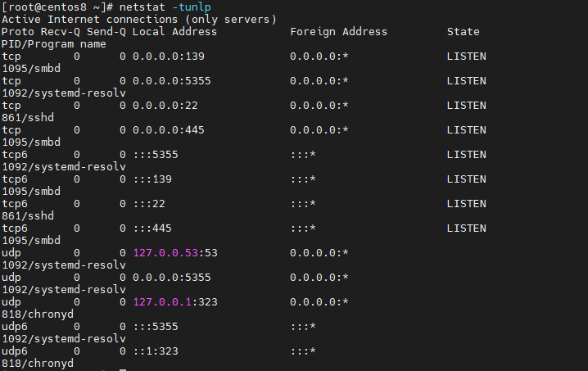

B
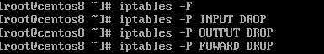

PART 2: the website question
https://tm255.open.ac.uk/wifi6network/
Page 1
Wi-Fi is a wireless technology that allows connectivity of devices such as computers (desktops and laptops), tablets and mobile devices such as smartphones to the internet i.e. a WLAN (Wireless Local Area Network). It is basically communication without the means of cables or wires. WI-FI has a set of protocols which are commonly referred to as IEEE 802.11 standards.
These standards are protocols and services that establish how fast or rapid the transfer of data is, between the router or the wireless access point and the connected devices to that particular WIFI network.
The standards began with 802.11 which supported a network bandwidth of up to two Megabytes per second and have since evolved from 802.11 to 802.11a, 802.11b, 802.11g, 802.11n, 802.11ac .The most recent one being the 802.11ax standard, which was launched in 2019.
Think of 802.11 as the base foundation and all other roll ups as a build to the groundwork that 802.11 had put in place. With each standard came increasing speeds, range, data throughput and better connectivity.
Page 2
AX Wi-Fi unlike its predecessor 802. 11ac came with improvements in data rate, capacity and range.
I terms of capacity, Wi-Fi 6 allows data to be transferred to many devices concurrently instead of broadcasting to one device at a go. It utilizes Multi User Multiple input Multiple Output (MU-MIMO) technology in modern devices and routers that are now capable to communicate with eight gadgets synchronously. MU-MIMO in this manner has also increased the range. Think of it as having a perfect smart home reality where you aren’t limited to just a few but many devices connected on one network without minimal interference or fail.
Orthogonal Frequency Division Multiple Access (OFDMA) not only increases the range but also accelerates data transfer and cuts down latency. With the transfer of data in sync, data can be moved at a faster rate and each transmission is developed to have maximum amount of information per transfer.
Signals are now packed with more information hence more efficiency by using 1024-QAM. There is also a wider channel thanks to the use of 160 MHz Channel. The fact that Wi-Fi 6 uses this technologies ensure the data transfer rate, range and capacity have been greatly improved compared to other wireless network transmissions.

Page 3
WPA3 (Wi-Fi Protected Access) is a sequence of security protocols launched in 2018 that provide a secure and safe method of protecting Wi-Fi traffic compared to the predecessor WPA2. It safeguards against handshake between devices and also makes harder to penetrate a network by password guessing.
WPA3 has made improvements in data security in the following ways:
- Password protection is improved
Encryption on WPA3 has been improved in the advanced enterprise security to 192 bits ensuring you are sheltered from hackers that target weak passwords. Moreover, unlike WPA2, attackers need to constantly interact with the Wi-Fi each and every time they guess a password making it more secure
- Better protection of your network devices
WPA3 has SAE (Simultaneous Authentication pf Equals) that makes it possible to avert key reinstallation attacks e.g. notorious KRACK, as compared to WPA2’s PSK(Pre-Shared Key) that let this attacks through. SAE not only makes it possible to safeguard all devices that are connected to the network but also provides an adequate defense in opposition to offline dictionary attacks.
- Secure public Wi-Fi network
Public networks will occasionally pass your data unencrypted especially when the network isn’t password protected. This is however different when it comes to WPA3 since it encrypts individual data even in open networks
In addition, SAE provides high level secrecy and way better data security benefits in open or public networks
Page 4
All current wireless technologies face several challenges in the first months after release. Wi- Fi 6 has its own objections when it comes clients who want to upgrade or deploy a new network. During deployment, there are restrictions that need to be addressed before moving forward with the network launch. Some of them include:
- IoT (internet of things) restrictions and rivals
A major application for 802.11 ax are the smart devices that are IoT enabled. This devices help in home automation and will usually require Wi-Fi to run. However, rivals such as Bluetooth, 5G and others have already penetrated the IoT market. The lack of top notch security features on Wi-Fi IoT devices brings about spit in choice when it comes the type of device to use. The competition’s devices therefore hinder the option of using 802.11 ax as the best option in the industry of IoT
- Hardware upgrade
Most enterprises would want to benefit from the feature Wi-Fi 6 offers as soon as possible. However, this comes with cost implications since the devices in use need to be able to support this technology.
The deployment of Wi-Fi 6 will therefore require substantial expenditure for operators or users that have devices capable of handling this improvements. Without proper finances in such a scenario, the deployment of the network gets held up

Page 5
Both 5G and Wi-Fi 6 are considered the most recent versions of their technologies. 5G is the next cellular generation from the previous LTE (Long-Term Evolution) and LTE advanced. Wi-Fi 6(802.11ax) on the other hand represents the latest standard of wireless network transmissions.
5G and Wi-Fi 6 have the following differences:
- Range
Normally, 5G supports cases that need longer ranges as compared to Wi-Fi 6 which is mostly used in short range cases like a home or office environment.
The tiny 5G cells support a range of between ten and a hundred meters whereas the mmwave base station can cover a range of two meters indoors and three hundred meters outdoor
On the other hand, Wi-Fi 6 range is up to 100 meters
- Data rate
5G has a high bandwidth of 1Gbps and a high data rate of between 1 and 10 Gbps at Peak and a 100 Mbps at Cell Edge
Wi-Fi 6 has a higher data rate than 5G. It’s about 600Mbps on the low and 9.6 Gbps at Peak
- Performance
5G’s roaming support ensures exceptional mobility. In addition, soaring data rates and bandwidth can be accomplished by employing aggregation and immense MIMO
Wi-Fi 6 on the other hand provides a reduced latency and overhead due to its scheduling techniques making it also easier for concurrent transmissions from different users

